Poster submission
Dr. Bastian Arlt
Anton Paar Germany GmbH, Hellmuth-Hirth-Str. 6, D-73760 Ostfildern, Germany
Bastian.Arlt@anton-paar.com
Title
Extended Technologies for Stability Analysis of Suspensions
Abstract
The size and stability of nano- and microparticles are crucial to their function, processing and transport properties. Anton Paar now introduces the light scattering devices for particle analysis that gives accurate insight into dispersed particle systems. The device determines particle size, zeta potential, and molecular mass by using light-scattering technology. We are going to present latest technology developments for the stability analysis. The formerly known PALS method is replaced by the faster and more reliable cmPALS method.
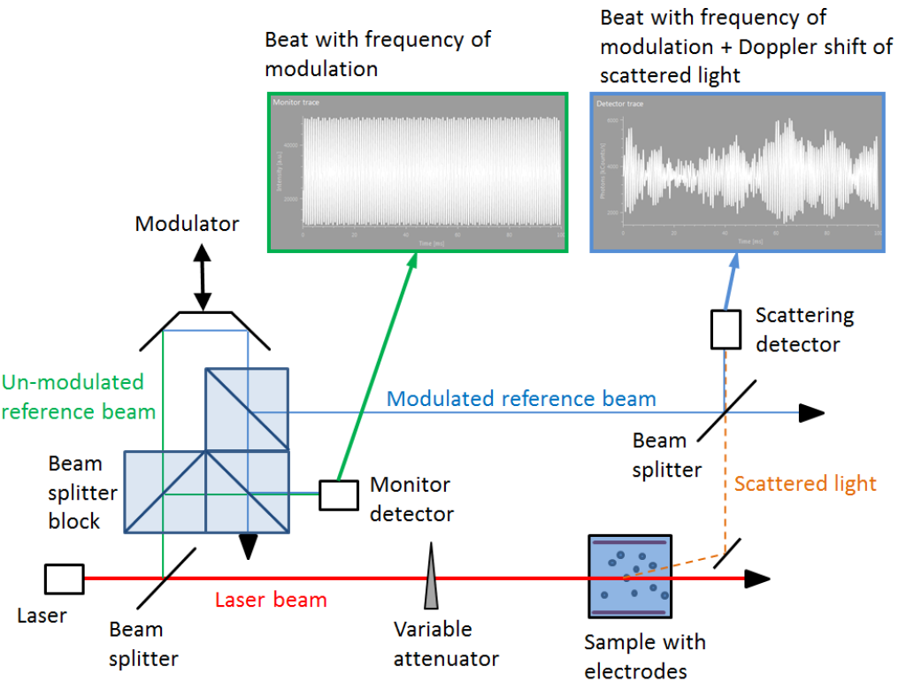
Technical sketch of the patented cmPALS method.
We show the technological advances, technical requirements for the device, your benefits and new geometry of the measurement cells. The sum of these improvements is breath taking and will increase accuracy and working efficiency by simultaneously minimizing the experimental error.

