Hydrocolloid active films and coatings to extend shelf life

Koro de la Caba

BIOMAT research group, University of the Basque Country (UPV/EHU), Engineering School of Gipuzkoa, Plaza de Europa 1, 20018 Donostia-San Sebastian

Our society is urged to act on key challenges, such as those related to food security, sustainability and bioeconomy, from a global approach (scientific, technical, environmental, economical, social) in order to provide competitive alternatives to the linear economy. In this context, the abundance and availability of some wastes and by-products from food processing industries can be used to obtain raw materials, promoting resource efficiency.¹ These food hydrocolloids have a great potential to develop antioxidant and/or antimicrobial films and coatings,² which can improve food quality, extend shelf-life and, thus, reduce food losses. The performance of protein- and polysaccharide-based films and coatings applied on food products will be analysed. Additionally, both the processes followed to extract proteins and polysaccharides and those used to manufacture active food packaging systems will be reviewed in order to address the feasibility of scaling-up production. Finally, the environmental aspects related to extraction and manufacture processes, as well as the end of life of packaging products, will be considered with the aim of closing the loop in the whole process involved in food packaging production.

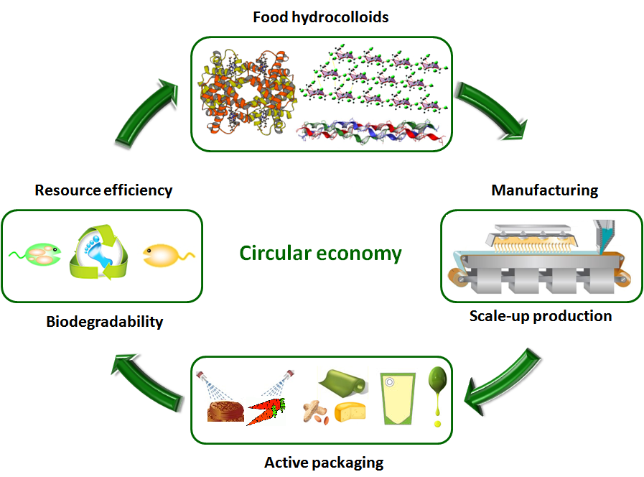

References:
1 Etxabide, A.,Uranga, J., Guerrero, P., de la Caba, K. (2017). Development of active gelatin films by means of valorisation of food processing waste: A review. Food Hydrocolloids, in press, http://dx.doi.org/10.1016/j.foodhyd.2016.08.021
2 Etxabide, A.,Coma, V., Guerrero, P., Gardrat, C., de la Caba, K. (2017). Effect of cross-linking in surface properties and antioxidant activity of gelatin films incorporated with a curcumin derivative. Food Hydrocolloids, 66, 168-175.

