Improving the functional properties of soy protein materials with thiol groups from chicken feathers

T. Garrido, J. Uranga, A. Etxabide and P. Guerrero

BIOMAT research group, Department of Chemical and Environmental Engineering, Engineering College of Gipuzkoa, Plaza de Europa 1, 20018 Donostia-San Sebastián, Spain

Soy protein isolate (SPI) and hydrolyzed keratin were employed to develop compression moulded films. In contrast to other studies, in which toxic chemicals or expensive methods are usually employed to hydrolyze feather keratin, in this research a novel approach was addressed. A solution of NaOH (1 M) was employed and the use of high temperatures was avoided during the process in order to obtain a simple, environmentally friendly and inexpensive method to hydrolyze feather keratin, which can be used for the development of thermoplastic films. In addition to the valorisation of agro-industrial waste, the main aim of the incorporation of hydrolyzed feather keratin into film forming formulations was to increase the sulphur content in the film forming formulation and, thus, the ability to form disulphide bonds, improving the chemical and thermal stability of the resulting films.
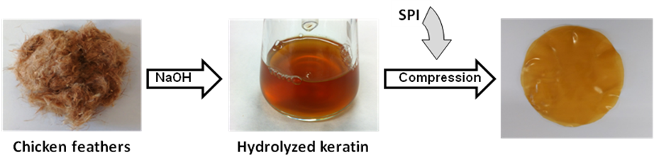

The employment of alkaline treatment at room temperature was an appropriate method to obtain hydrolyzed feather keratin, soluble in water and a natural source of sulphur to promote disulphide bonds and, thus, cross-linking in protein-based formulations. The chemical characterization of the keratin extracted from chicken feathers confirmed the high content on cysteine and also the significant changes produced in the protein structure, leading to the protein solubilisation. Further analyses of the films resulting from the blend of soy protein and hydrolyzed keratin showed the good compatibility among the components of the blend, leading to films with an enhanced thermal and dynamic-mechanical behaviour.

Acknowledgements
BIOMAT research group thanks the University of the Basque Country (UPV/EHU) for financial support (GIU15/03) and the Provincial Council of Gipuzkoa (OF215/2016 (ES)).

