A novel class of xanthan derivatives for preparing stable oil-in-water emulsions
Céline Fantou ª, Sébastien Comesse ª, Michel Grisel ª and Frédéric Renou ^{b}
ª NormandieUniv, UNILEHAVRE, FR 3038 CNRS, URCOM, 76600 Le Havre, France
^{b} Le Mans Université, IMMM UMR-CNRS 6283, Polymères, Colloïdes, Interfaces, 72085 Le Mans Cedex 9, France
Polysaccharides are widely employed in many industries such as food or cosmetic mainly to stabilize oil-in-water emulsions and to control their rheological properties. Among the others, xanthan gum is the most used due to its outstanding thickening properties of aqueous solutions. However, because of its poor interfacial properties, it requires the addition of an emulsifier to disperse and stabilize the oil droplets. Unfortunately, the use of low molecular weight surfactants has many disadvantages related to toxicological and environmental considerations. On this basis, macromolecular surfactants have been developed during the last decades, most being synthetics while the nowadays demand of natural ones is considerably growing. To overcome this problem, octyl residues were grafted onto the backbone of xanthan to confer new amphiphilic properties^{1,2}. Moreover, xanthan can adopt two different conformations³, with distinct rheological properties⁴ depending on the experimental conditions: an ordered semi-rigid helical structure or a disordered flexible coil.
The objective of the present work is to study and understand the phenomenon involved in the stability of oil-in-water emulsions containing amphiphilic xanthan.
Oil-in-water emulsions using no surfactant but containing pristine or modified xanthan grades have been studied and compared. As expected in emulsion, unmodified xanthan is not able to stabilize the emulsions as phase separation occurred within only few hours. Oppositely, emulsions obtained with modified xanthan appear stable over months⁵ (see fig. 1).
These results clearly demonstrate the high potential for hydrophobically modified xanthan as emulsion’s stabilizer which has been studied as a function concentration and grafting density.
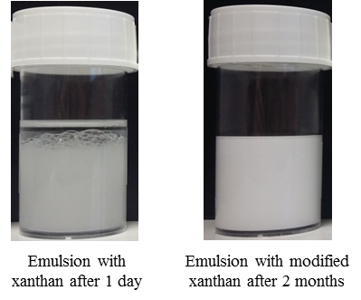

- Roy, A.; Comesse, S.; Grisel, M.; Hucher, N.; Souguir, Z.; Renou, F. Hydrophobically Modified Xanthan: An Amphiphilic but Not Associative Polymer. Biomacromolecules 2014, 15 (4), 1160–1170.
- Fantou, C.; Roy, A. N.; Dé, E.; Comesse, S.; Grisel, M.; Renou, F. Chemical Modification of Xanthan in the Ordered and Disordered States: An Open Route for Tuning the Physico-Chemical Properties. Carbohydr. Polym. 2017, 178, 115–122.
- Milas, M.; Rinaudo, M. Conformational Investigation on the Bacterial Polysaccharide Xanthan. Carbohydr. Res. 1979, 76, 189–196.
- Choppe, E.; Puaud, F.; Nicolai, T.; Benyahia, L. Rheology of Xanthan Solutions as a Function of Temperature, Concentration and Ionic Strength. Carbohydr. Polym. 2010, 82 (4), 1228–1235.
- Fantou, C.; Comesse, S.; Renou, F.; Grisel, M. Hydrophobically Modified Xanthan: Thickening and Surface-Active Agent for Highly Stable Oil in Water Emulsions. Carbohydr. Polym. 2019, 205, 362-370.

