Non-invasive evaluation of weighting agent efficiency for beverage emulsion stabilization

C. Tisserand, R. Ramsch, G. Brambilla, G. Meunier

Formulaction, 3-5 Rue Paule Raymondis, 31200 Toulouse, France

Beverage emulsions are prepared in a concentrated form and later diluted to produce the finished beverage. These diluted emulsions are unstable. Most common deterioration process is creaming named ring formation around the neck of the container, corresponding to a thin concentrated phase formation below meniscus. Weighting agents (like BVO for Brominated Vegetable Oil, EG for Ester gum…) are largely used to minimize the density difference between oil droplets and the aqueous phase and stabilize the emulsion. They also contribute to opacity which is an important property of fruit beverage as is enhances their juice-like appearance. Most of the manufacturers work on new ingredients to remove classical weighting agents as they are considered as non-safe for health concern.
This work aims to propose a method to assess the efficiency of a new natural weighting agent (NWA) at three concentrations compared to Brominated Vegetable Oil (BVO) using Static Multiple Light Scattering (SMLS)¹ device. The heart of the optical scanning analyser is a detection head, which moves up and down along a flat-bottomed cylindrical glass cell (see figure). The detection head is composed of a pulsed near infrared light source (wavelength = 880 nm) and two synchronous detectors. The transmission detector (at 0°) receives the light, which goes through the sample, while the backscattering detector (at 45°) receives the light scattered backward by the sample. The detection head scans the entire height of the sample, acquiring transmission and backscattering data every 20 µm for systems in a large size (10nm-1mm) and concentration (10⁻⁴-95% v/v) range. The repetition of the acquisition of these profiles enables to monitor the evolution of concentration and size of the system versus time.
We propose a description of the weighting agents, we will show the advantages of using SMLS to determine the most suitable agent, by the quantification of creaming rates, which reflects ring formation, and by the determination of the final layer ring size.
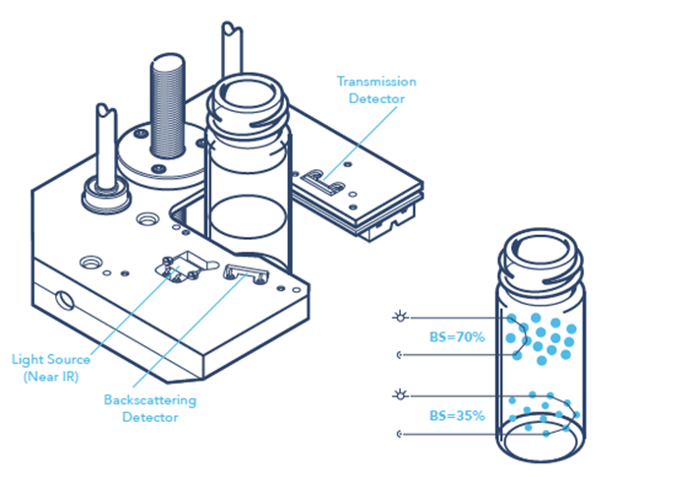
Figure 1. Principle of measurement by SMLS

References:
1 O. Mengual, G. Meunier, I. Cayré, K. Puech, P. Snabre. (1999). Talanta, 50(2), 445-456.

