Investigation of casein micro-particle in blend casein/pectin films

Y Zhuang¹, J Sterr¹, U Kulozik² and R Gebhardt¹

¹ Chair of Food Process Engineering and Dairy Technology, Techniche Universität München
85354, Freising-Weihenstephan, Germany
² Chair of Food Packaging Technology, Techniche Universität München, 85354, Freising-Weihenstephan, Germany
³ Research Centre for Nutrition and Food Science (ZIEL) – Section Technology, Techniche Universität München, 85354, Freising-Weihenstephan, Germany

Pectin is widely used as stabilizer in acidized milk product to prevent protein aggregation. Recently application of pectin as fat replacer or as additional layer for mixed layer emulsions aim to introduce novel functionality in food products. However, the role of pectin in blend protein films is still not clear. Our latest study reveals that pectin triggers formation of casein micro-particles during solution casting. Confocal Raman microscopy was applied to revealed their composition and spatial dimension in resulting films. Peaks in the Raman spectra corresponded to those found in films prepared by either casein or pectin. This suggested that no conformational changes occurred after mixing. Raman images revealed incompatibility of both polymers because particles consisted of casein only and the surrounding matrix of pectin¹. Deformation of micro-particles into an oblate shape took place during film formation, which is similar to deformation of single casein micelle in film matrix². In dried films, an empty space between casein and pectin was found in lateral dimension. In contrast, casein micro-particles overlapped with the pectin matrix in vertical dimension. Our finding provides basic theory to the formation of casein micro-particle in blend films. These micro-particles can be further used as either targets to encapsulate bioactive substances or building blocks for bio-based materials.

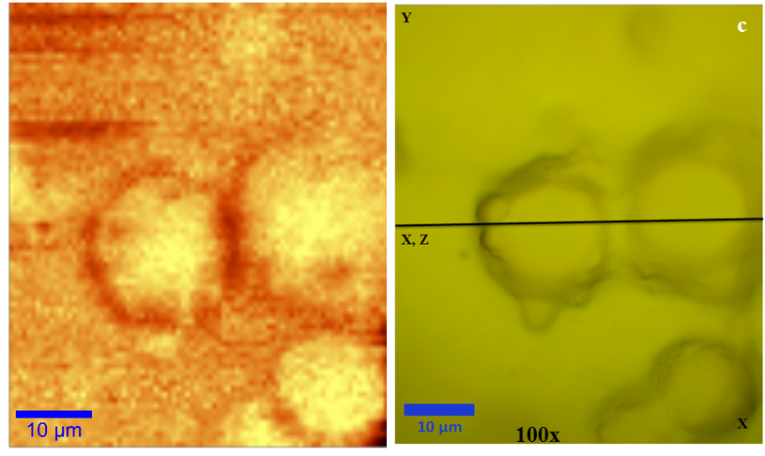
Fig. Left: Raman image generated by integration over the CH-stretching band; Right: Surface of a film prepared from CM/HM-pectin mixture;

References:
1 Zhuang, Y., Sterr, J., Kulozik, U and Gebhardt, R. (2015). Application of confocal Raman microscopy to investigate casein micro-particles in blend casein/pectin films. International Journal of Biological Macromolecules, 74. 44-48.
2 Gebhardt, R., Kulozik, U. (2014). Simulation of the shape and size of casein micelles in a film state. Food & Function, 5(4), 780-785

