Abstract: Vegan and clean label emulsions by using citrusfibre ; David Gebhardt

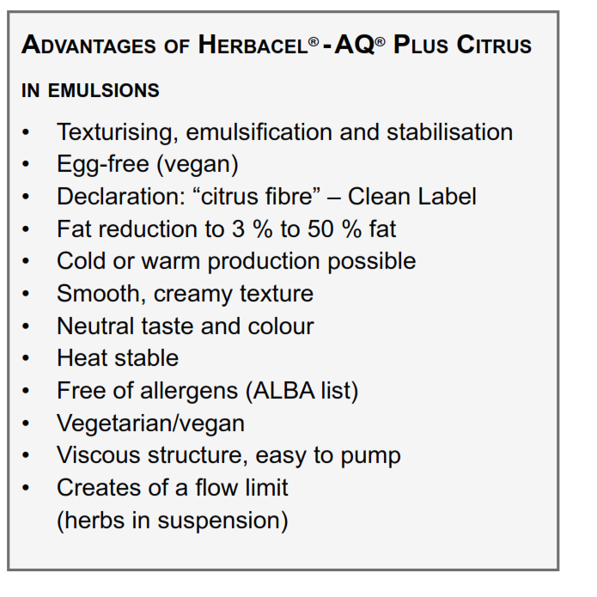
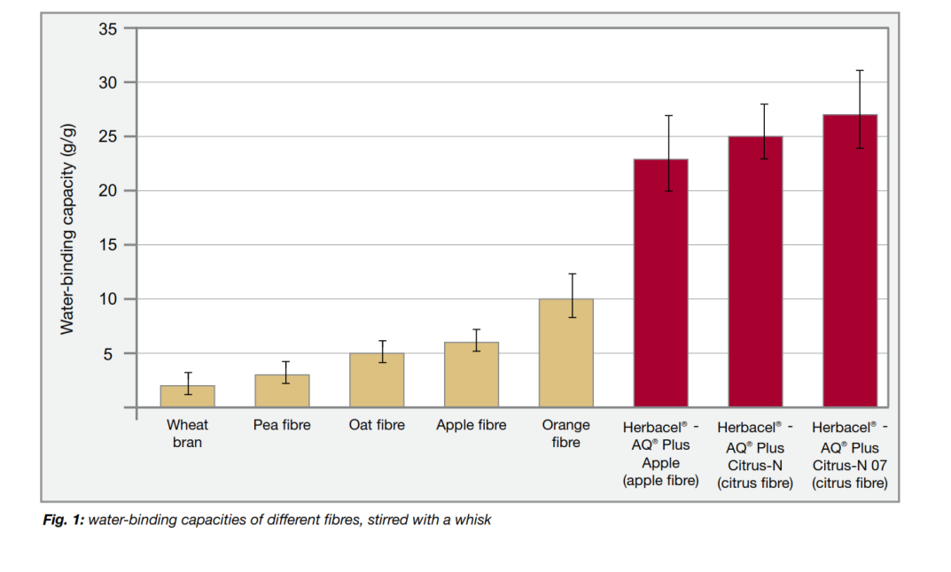
The use of animal raw materials in the food sector is increasingly being questioned or completely rejected by the growing vegetarian and vegan consumer group. For the area of ​​ emulsions, the frequently used hen's egg thus experiences increased refusal, in addition to allergy. The absence of this animal raw material makes the use of other emulsifying ingredients necessary. Due to the advancing clean-label development, the industrial manufacturers are increasingly striving to avoid the use of food additives, to keep the processing level of the raw materials low and to use largely sounding ingredients. We also pay attention to a short list of ingredients. For this reason, E-number free plant fibres, such as the Citrus fiber Herbacel AQ Plus Citrus, are more within the focus The high-water binding citrus fiber shows a very high water binding capacity of up to 50 g / g after the mechanical processing in water (homogenizer, Stephan mixer, Fryma-Koruma or similar). With the subsequent addition of an oil phase with further action of shearing forces, stable emulsions can be produced up to a fat content of 50%. The texture properties of vegan emulsions can be further optimized by combining Herbacel AQ Plus Citrus with pectin. On the one hand pectin provides an improved surface gloss. On the other hand, the mouth feel is further improved. By setting up a flow boundary, Herbacel AQ Plus Citrus is able to keep herbs contained in dressings when it is used in dressings. As a result, an optically-responsive product can be guaranteed over the storage period.
