Effect of protein source on the morphology and flow properties of protein-based emulsion particles used as texture modulators

Luca Amagliani, Elyes Ben Sassi, Johann Buczkowski and Christophe Schmitt

Nestlé Research, Nestlé Institute of Material Sciences, Vers-chez-les-Blanc, CH-1000 Lausanne 26, Switzerland

The formation of aggregated protein structures upon heating is independent of the globular protein used for particulates and fibrils ^{[1, 2]}. It mostly depends on the degree of electrostatic repulsion between denatured monomers rather than the specific amino acid sequence of the protein. This suggests that different globular proteins might be used interchangeably to produce aggregates with similar morphology, physicochemical and functional properties. This is of high relevance for food formulation, as it would allow for partial or total replacement of animal proteins with plant ones in several products without compromising functionality.
The present study compares the effect of heating (95°C for 90 s) formulations based on globular proteins with close isoelectric points (whey, pea, potato and soy), with the same nutrient composition (3 wt% protein; pH 6.6; 0-0.95 wt% NaCl; 0-0.10 wt% CaCl₂; 0-5 wt% high oleic sunflower oil) and processed using the same conditions (homogenization and shearing post-heat treatment). The aggregation yield, morphology and functional properties of the resulting aggregates were characterized. Some trends in the aggregation behaviour among the different protein-based formulations were identified, but protein-source dependence seemed to matter. In oil-free formulations, salts addition promoted a considerable increase in aggregation yield and particle size, which resulted in viscosity build up, particularly for whey protein-based formulations. Interestingly, addition of oil to the various formulations with added salts led to a further increase in the aggregation yield and a decrease in particle size (Fig. 1). Furthermore, addition of oil to plant protein-based formulations promoted a marked increase in viscosity upon heat treatment, whereas the opposite phenomenon was observed for whey protein-based formulations.

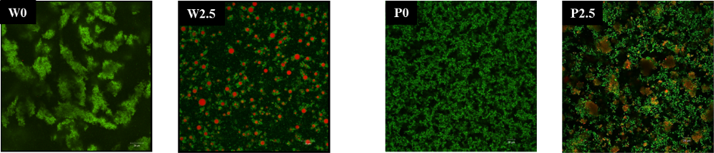
Fig. 1: CLSM images of whey (W) and potato (P) protein-based formulations containing 0 wt% (W0 and P0) and 2.5 wt% (W2.5 and P2.5) high oleic sunflower oil.

The differences observed among the various protein-based aggregate systems in terms of morphology, physicochemical and functional properties may be ascribed to differences in their sensitivity towards added salts and in their emulsifying ability. We conclude, therefore, that formulation and processing need to be adapted to the protein used if aggregate systems with similar properties want to be obtained starting from different protein sources.

References:
1 Krebs, M.R., G.L. Devlin, and A.M. Donald, Protein particulates: another generic form of protein aggregation? Biophys J, 2007. 92(4): p. 1336-42.
2 Dickinson, E., Colloids in food: ingredients, structure, and stability. Annual review of food science and technology, 2015. 6: p. 211-233.

