Consolidated bioprocessing of starch based on encapsulation technology for alcohol production
A. Drosos*, A. Tourloukis, Z. Banti, M. Kanellaki, A. A. Koutinas
Department of Chemistry, University of Patras, GR-26504 Patras, Greece
* Corresponding Author: thanosdro@gmail.com
Abstract
The concept of this study is based on two bilayer cell factories (BCFs) of bacterial cellulose (BC) or tubular cellulose (TC) coating with hydrocolloid alginates (ALG) as immobilization carriers for alcohol production from starch.
As illustrated in Fig. 1, the BCF₁ consists of S. cerevisiae cells immobilized on BC fibrils as internal layer coating with encapsulated spores of A. awamori in ALG as external layer. The BCF₂ consists of S. cerevisiae cells immobilized on TC pores as internal layer coating with encapsulated spores of A. awamori in ALG as external layer.
Both BCFs were designed to be suitable for the consolidated bioprocessing (CBP) of starch viz. the one step treatment (amylases production, starch hydrolysis and fermentation) of starch for alcohol production. The experimental work focused on: (i) examining the concentration of the BCFs and (ii) the recovering of the used BCFs via re-using twice for CBP of 5 % (w/v) starch at 30ºC.
The alcohol concentration was analyzed by HPLC, examining the proper operation of the BCFs. Finally, SEM/EDS and FTIR spectra analysis were performed to evaluate the preparation of the BCFs. The results indicated that the objective of designing of the novel BCFs are very promising for value-added chemicals in the framework of White biotechnology.
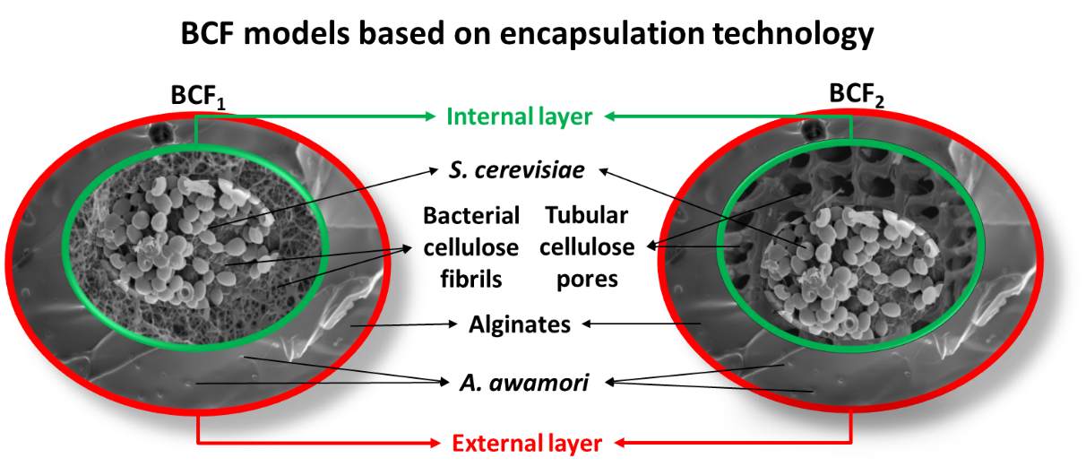
Fig. 1. Appearance of the BCFs’ design

