Pickering emulsions stabilised by pea protein microgel particles: Influence of pH and ionic strength
Shuning Zhang¹, Melvin Holmes¹, Rammile Ettelaie¹ and Anwesha Sarkar¹
¹Food Colloids and Bioprocessing, University of Leeds, UK
There is burgeoning research and industrial interests for designing ultra-stable plant protein-based emulsions. In this study, we have designed Pickering emulsions (20 wt% sunflower oil) stabilized by plant protein-based particles (1 wt% protein) and investigated their stability as a function of pH and ionic strength. We created a new class of Pickering stabilizer i.e. pea protein microgel (PPM) particles of ~ 232 nm hydrodynamic diameter (D_{h}) with polydispersity index (PDI) ~ 0.2, using a top down technique^{1,2}. This top down technique involves breaking down a heat-set pea protein gel (8 wt% protein) by two stage homogenization process at 250/50 bars for 2 passes into PPM particles. The pI of the PPM particles was around pH 5.0 with the net surface charge being close to zero. The aqueous dispersion of PPM particles had D_{h} ranging from 200 to 400 nm at neutral to alkaline pH (pH 7.0-9.0) with high negative charge density (-30 to -35 mV). However, the particles showed high degree of aggregation (D_{h} >2000 nm, PDI > 0.6) in acidic pH (pH <4.0). With increasing ionic concentration (1-250 mM NaCl), the zeta-potential of particles changed from -40 mV to -8 mV due to charge screening effects. The PPM particles could successfully stabilize oil droplets with mean droplet size (d₄₃) ~ 32 µm at pH 7.0. Interestingly, adjusting the pH of Pickering emulsion from pH 7.0 to pH 3.0 resulted similar sized droplets with aggregation of PPM particles at the particle-laden interface providing a better surface coverage as compared to that at pH 3.0, supported by confocal images (Figure 1). In summary, these findings highlight PPM as a suitable Pickering stabilizer and pH as a suitable trigger to tune the surface properties of the droplets, latter might provide benefits in controlling gastric digestion of these emulsions.
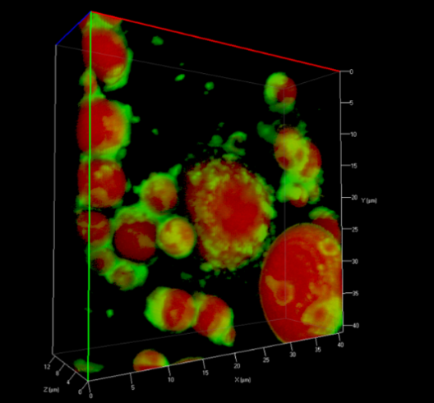

Figure 1. Confocal micrographs of PPM-stabilized Pickering emulsions at pH 7.0 (left) and after adjusting the pH to pH 3.0 (right). Spherical oil droplets were stained with Nile red which is presented in red, and protein microgel particles were stained with Nile blue which is presented in green.

References:
- Sarkar, A., Kanti, F., Gulotta, A., Murray, B. S., Zhang, S. (2017). Aqueous lubrication, structure and rheological properties of whey protein microgel particles. Langmuir 33 (51), 14699-14708
- Sarkar, A., Murray, B. S., Holmes, M., Ettelaie, R., Abdalla, A., Yang, X. (2016). In vitro digestion of Pickering emulsions stabilized by soft whey protein microgel particles: influence of thermal treatment. Soft Matter 12 (15), 3558-3569.

