Saponin-content plants as natural nanoemulsions stabilizers for food products
Maciej Jarzębski¹, Wojciech Smułek², Hanna Maria Baranowska¹
¹Department of Physics and Biophysics, Poznań University of Life Sciences, 38/42 Wojska Polskiego Str., 60-637 Poznań, Poland
²Institute of Chemical Technology and Engineering, Poznan University of Technology, 4 Berdychowo Str., 60-965 Poznań, Poland

There is a high demand to replace artificial surfactants and stabilizers in food products with natural raw materials usually taken from plants. One of the well-known groups of active agents delivered from plants is saponins. Here, we presented the current status of our research focused on the saponin-reach plant-based extracts. As a base, we chose extracts from Saponaria officinalis L. (SOL) (Jarzębski et al. 2020), Aesculus hippocastanum L. (AHL) (Jarzębski et al. 2019), and Sapindus Mukorossi (Soap nuts – SN). The effect of the addition of the extracts in oil in water hemp seed oil (HSO) emulsion was evaluated. As stability tests, we performed visual observation (including microscopy), centrifugation tests, and determining droplet size distribution using the dynamic light scattering technique (DLS). Our examinations proved that there is a high demand of application a minimum of two techniques for emulsion droplet size validation and verification of emulsion stability i.e. DLS supported with light microscopy (see fig. 1).
It should be highlighted that the proposed two-step emulsion preparation process (Pratap-Singh et al. 2021) resulted in an emulsion system with good stability. Interesting results were observed in the systems with SN used as a stabilizer. The samples showed good stability, and visual high turbidity, even after 3 months (stored in normal room conditions, without the protection of light, etc.).
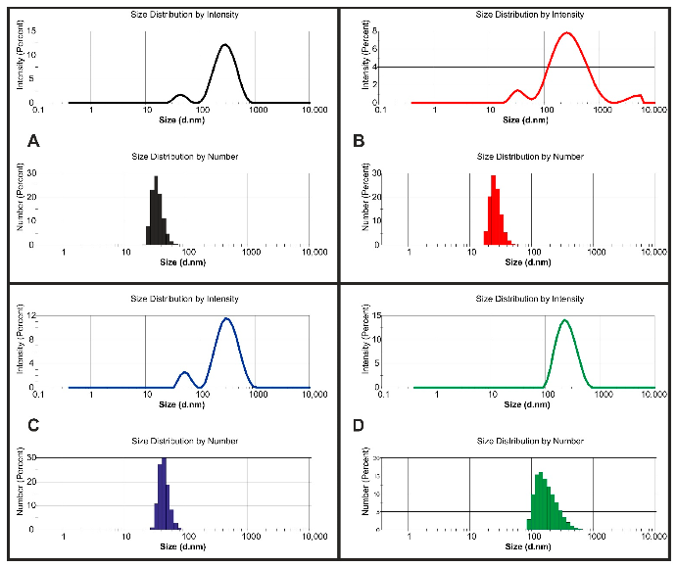 | 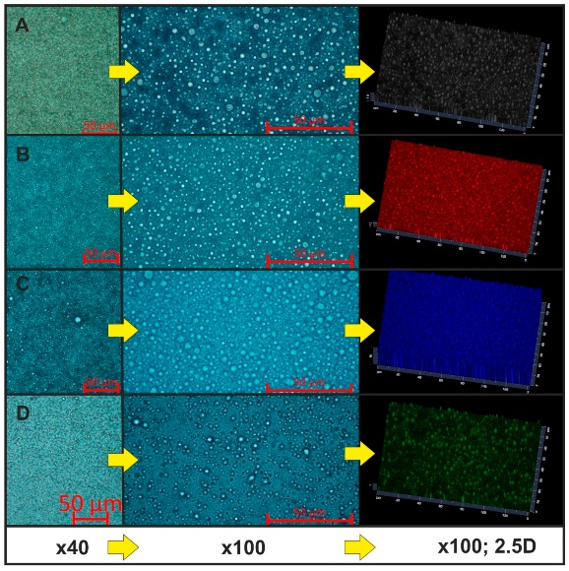
Fig. 1 Droplet size distribution obtained by DLS and microscopic images of the nanoemulsions (taken from (Smułek et al. 2021) under the Creative Commons Attribution License

Jarzębski, Maciej, Przemysław Siejak, Wojciech Smułek, Farahnaz Fathordoobady, Yigong Guo, Jarosław Pawlicz, Tomasz Trzeciak, et al. 2020. “Plant Extracts Containing Saponins Affects the Stability and Biological Activity of Hempseed Oil Emulsion System.” Molecules 25 (11): 2696. https://doi.org/10.3390/molecules25112696.
Jarzębski, Maciej, Wojciech Smułek, Przemysław Siejak, Joanna Kobus-Cisowska, Danuta Pieczyrak, Hanna Maria Baranowska, Jarosław Jakubowicz, Mateusz Sopata, Tomasz Białopiotrowicz, and Ewa Kaczorek. 2019. “Aesculus Hippocastanum L. Extract as a Potential Emulsion Stabilizer.” Food Hydrocolloids 97 (May). https://doi.org/10.1016/j.foodhyd.2019.105237.
Pratap-Singh, Anubhav, Yigong Guo, Sofia Lara Ochoa, Farahnaz Fathordoobady, and Anika Singh. 2021. “Optimal Ultrasonication Process Time Remains Constant for a Specific Nanoemulsion Size Reduction System.” Scientific Reports 11 (1): 1–13. https://doi.org/10.1038/s41598-021-87642-9.
Smułek, Wojciech, Przemysław Siejak, Farahnaz Fathordoobady, Łukasz Masewicz, Yigong Guo, Małgorzata Jarzębska, David D. Kitts, et al. 2021. “Whey Proteins as a Potential Co-Surfactant with Aesculus Hippocastanum L. as a Stabilizer in Nanoemulsions Derived from Hempseed Oil.” Molecules 26 (19): 5856. https://doi.org/10.3390/molecules26195856.

